Chapter 28:

America in a World at War

The AP instructional strategies discussed below for Chapter 28 of American

History: A Survey focus especially, but not exclusively, on the following themes developed by the AP U.S. History Development Committee: American Diversity, American Identity, Culture, Economic Transformations, Globalization, Politics and Citizenship, and War and Diplomacy. This chapter, as well as the primary documents selected below, follow the content guidelines suggested for the twenty-eighth unit in the AP Topic Outline − The Second World War.

Top-Ten Analytical Journal.

Defining the chapter terms in their journals will help students better understand:

- The efforts of the federal government to mobilize the nation's economy for war production.
- The effects of American participation in the war on the Depression and on New Deal reform.
- The changes that the wartime involvement brought for women and racial and ethnic minorities.
- The contributions of the United States military to victory in North Africa and Europe.
- The contributions of the United States military to victory in the Pacific.

Each of the terms below contributes to a comprehensive understanding of the America’s involvement in World War II and the way in which the war affected those on the home front. As your students define these terms, encourage them to demonstrate why each person, event, concept, or issue is important to a thorough understanding of this chapter.

General Douglas MacArthur
Admiral Chester Nimitz
General George C. Marshall
General George S. Patton
Siege of Stalingrad
The Holocaust
Anti-Semitism
Union power
Office of Price Administration
War Production Board
Wartime technology
- Phillip Randolph
Fair Employment Practices Commission
Congress of Racial Equality (CORE)
Native American Code-Talkers
Indian Reorganization Act of 1934
Braceros
Zoot-Suit Riots
“Rosie the Riveter”
USO
The “Swing Era”
Japanese Internment
Election of 1944
Dresden firebombing
General Dwight D. Eisenhower
D−Day
Battle of the Bulge
V-E Day
Battle for Okinawa
Manhattan Project
Hiroshima and Nagasaki

Getting students started on their journals. Remind students that they must analyze and synthesize their understanding of these terms in two ways:

- by creating “Top-Ten” lists of their own within their journals at the end of each chapter; and
- by justifying in their journal why their terms are essential to an understanding of “America in a World at War.”

Journal entry example. Following is an example of how students might describe “Braceros” and its importance to an overall understanding of “America in a World at War.”

Braceros were Mexican contract laborers who were recruited to come to the United States during World War II to help with labor shortages especially in the Southwestern and Pacific Coast areas. These contract laborers soon became the second largest group of migrants to American cities in the 1940s.

Era 8: “World Crisis and War in a New International and Domestic Environment” Assignment. Because the students have completed the eighth historical era in their book by reading Chapters 27 and 28, it is time to come together as a class to synthesize individual student lists into the eighth class “Top-Ten” list. The night before this discussion takes place, assign the following for homework:

Journal Assignment. Examine the 10 terms for each chapter that you have previously identified as necessary to a complete understanding for Chapters 27 and 28 in the textbook. Then, narrow down your list to a total of ten terms that best describe the era. Be prepared to justify your choices in class tomorrow.

During class, ask students to analyze and debate the importance of terms they have selected and challenge them to create a composite “Top Ten” for the era. Ask a student to put these words on a large poster where it will remain throughout the academic year. Then have the students complete the following homework assignment in their journals:

- Taken as a whole, what does the class “Top-Ten” list tell you about the political, social, economic, and religious issues of this era of American history?
- Are there any terms that you think must be added to the “Top-Ten” list that the class as a whole did not include? If so, explain why you believe they should be added.
- What clues do they think the “Top-Ten” list for this era might provide for an understanding of the next era of U.S. History?

Free-Response Questions.

- Compare and contrast the impact of the war on the many ethnic, gender, and racial groups in America.

Some things to look for in the student response.

- Possible thesis statement: During the four years of the war, American society and Americans underwent many changes. Specifically, African Americans, Native Americans, Japanese Americans, Mexican Americans, and women experienced many changes in their daily lives.

- African Americans. Throughout the war, many blacks from the rural South migrated to the northern industrial cities where many found industrial jobs that improved their economic conditions. Hundreds of thousands entered the military and served courageously during the war. But these improvements were tempered by the prejudices and discriminatory traditions of white America. As blacks entered some cities, racial violence broke out. When blacks protested serving in segregated divisions of the military, riots also occurred.

- Native Americans. The lives of Native Americans were affected in at least two important ways − through service in the military and through jobs in war plants. Over 25,000 Native Americans served in World War II both in combat and as code talkers working in military communications with their native languages that the enemy could not understand. Over 70,000 Native Americans left their reservations to work in factories that supplied the war effort. After the war, however, most of these job opportunities were no longer available.

- Mexican Americans. Due to the labor shortages both in the agricultural and industrial regions of the U.S., the American and Mexican governments agreed to the bracero program whereby Mexican contract laborers came to the U.S. to work for a limited time. As more braceros came to the U.S., they settled in Mexican-American neighborhoods where some of the young people joined groups that wore distinctive cultural clothing considered outrageous, rebellious, and defiant by white, middle-class Americans. The result was the Zoot Suit Riots in Los Angeles, in which white sailors came into Mexican-American communities and attacked zoot-suiters. When they tried to fight back, the police arrested the Mexican-Americans and the city later passed a law forbidding the wearing of zoot suits.

- Japanese Americans. About 127,000 first-generation and native-born citizens of the United States were imprisoned in internment camps for the duration of the war. Fearing that the Japanese might aide the enemy, President Roosevelt authorized internment, which was later constitutionally upheld by the U.S. Supreme Court. After the war, most Japanese could not return to their communities as they had not only lost all of their property and their businesses, but they were still the target of prejudice, harassment, and mistrust. Their lives were forever changed by their war experience.

- Women. By the war’s end, the number of women in the work force had increased by almost 60 percent. The role of wage-earning women was especially felt in the industrial work force where they worked in war plants at jobs traditionally believed to be “men’s work;” in service-sector jobs where they worked as clerks, secretaries, and typists; and in the military within gender-segregated units like the WACs and the WAVEs. Women also joined unions in higher numbers than ever before. Women who elected to stay at home were also enlisted in the war effort. They were encouraged to raise victory gardens, to can food, and to prepare meals that fit their food ration coupons. Some were recruited by the USO to serve as hostesses in their clubs, and by military bases to join “dance brigades” where they had social evenings with soldiers. Regardless of how they served during the war, women (especially married women) entered areas of society previously believed to be inappropriate for them.

- Possible conclusion: Clearly, the lives of some groups of Americans were radically changed by the war years − especially those of the Japanese Americans and women. The lives of the interned Japanese were forever scarred by the experience of being imprisoned in their own nation and losing all of their possessions. The lives of many women were forever changed as some entered new areas of American society and others enjoyed their jobs in the workplace − jobs that they reluctantly gave up after the war. Other groups − especially African Americans, Native Americans, and Mexican Americans − experienced some positive economic changes during the war in terms of jobs. However, the ramifications of their movement into new areas of society were often negative. Further, at the war’s end, many lost their jobs.

2. Assess the various historical debates that have surrounding the decision to drop the atomic bomb. Given what you know about the facts and these debates, do you think Truman made the right choice? Why or why not?

Some things to look for in the student response.

- Possible thesis statement: Ever since the bombs were dropped on Hiroshima and Nagasaki, controversy has raged over Truman’s decision and the motives behind his choice. The debates surrounding Truman’s decision generally fall into two camps: those who feel the attack was unnecessary as the Japanese would have surrendered within a very short time, and therefore, Truman had other motives for dropping the bomb; and those who argue the attack was a necessary, simple military decision as it was the only way to stop Japan’s leaders.

- Attack was unnecessary. Historian Gar Alperovitz’s two books argue that Japan would have surrendered soon without the bomb and that Truman made his decision in order to force Stalin to be more in line with American demands. Martin Sherwin agrees, arguing that Truman believed that the atomic bomb in and of itself would be enough to make Stalin more manageable.

- Attack was a necessary, simple military decision. Truman’s memoirs point to this decision. He felt the bomb must be dropped in order to prevent an American mainland invasion that would cost as many as a million lives. The memoirs of many of his contemporaries support this position: Winston Churchill, Secretary of War Henry Stimson, and Truman’s senior military advisors. Historian Herbert Feis also takes this stand, as do David McCullough, Alonzo Hamby, and Robert J. Donovan.

- Right choice? (This answer will vary from student to student.)

- Possible conclusion: While most of the debate falls within the two camps above − the necessary versus necessary arguments − a few others have argued that regardless of Japanese intentions, using the terrible new weapon was not a moral or rational choice. A more controversial and as yet unsubstantiated interpretation is that the racialized image of Japan as a subhuman species may have contributed to America’s willingness to bomb Japanese cities.

Historians, Historical Detection, and DBQs.

The following DBQ and its supportive primary documents will help students gain a better understanding of the role women played in World War II and the way in which propaganda shaped that role. Remind your students that when scoring the AP exams, the readers will expect to see a coherent essay that includes two required components: key pieces of evidence from all or most of the documents and a well-organized narrative drawing on knowledge from textbook readings and classroom discussion.

DBQ: World War II drew increasing numbers of women into new roles. Using your knowledge of women’s roles during the war, as well as your interpretation of the posters and artwork included below that were produced during the war, assess their involvement in the military and on the home front.

Documents:

- “Soldiers Without Guns.” (Library of Congress)
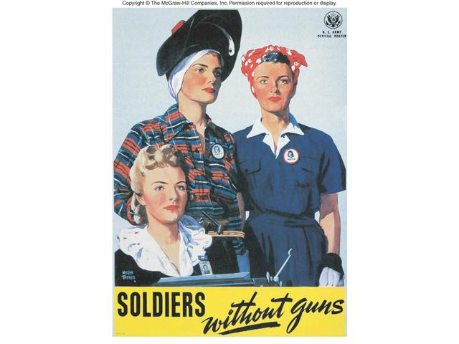

- “Join the WAAC,” 1941. (PSI document. "Attention, Women! Join the WAAC: Women's Army Auxiliary Corps, U.S. Army." 1941-1945. Records of the Office of Government Reports, National Archives and Records Division, ARC Identifier: 513892.)
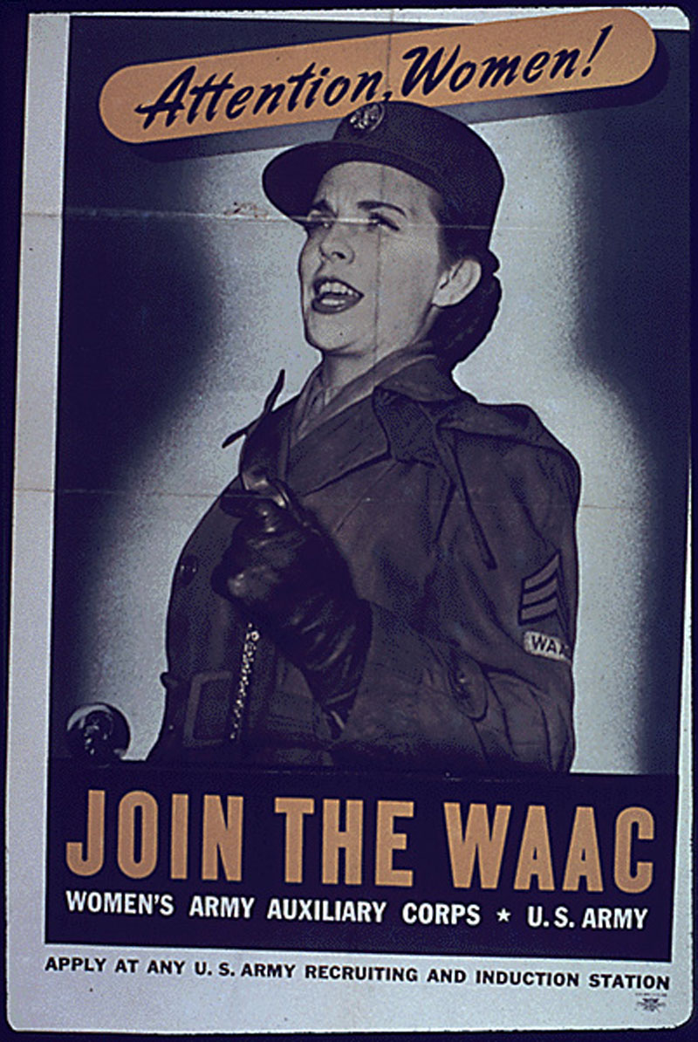
- “Victory Waits on Your Fingers,” 1941. (PSI Document. "Victory waits on your fingers -- Keep 'em flying, Miss U.S.A.," 1941-5. Office of Emergency Management. Office of War Information. Domestic Operations Branch. Bureau of Special Services (03/09/1943-08/31/1945). Record Group 44, Records of the Office of Government, Still Picture Records LICON, Special Media Archive Services Division, College Park, MD.)
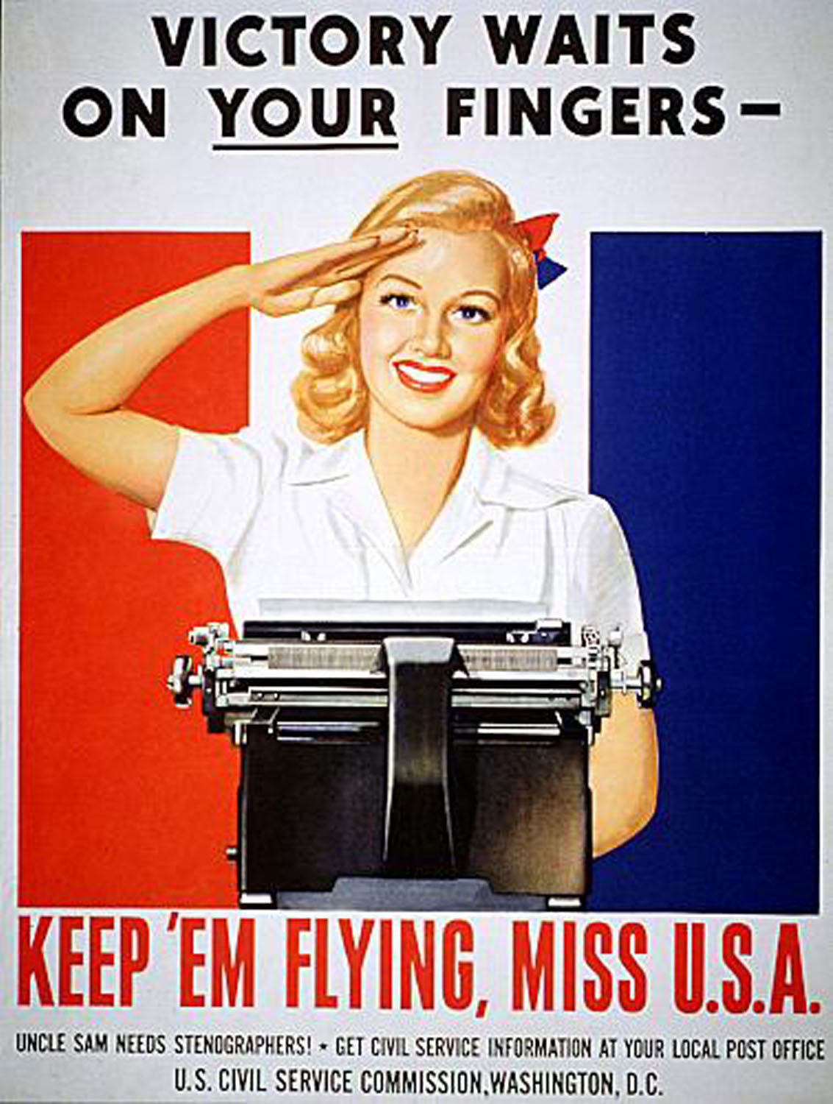

- “Longing won’t bring him back sooner,” 1941. (PSI Document. “War Manpower Commission, "Longing won't bring him back sooner. Get a War Job!," 1941-1945. Courtesy of the still Picture Records LICON, Special Media Archive Services Division, National Archives, ARC Identifier: 513840.)
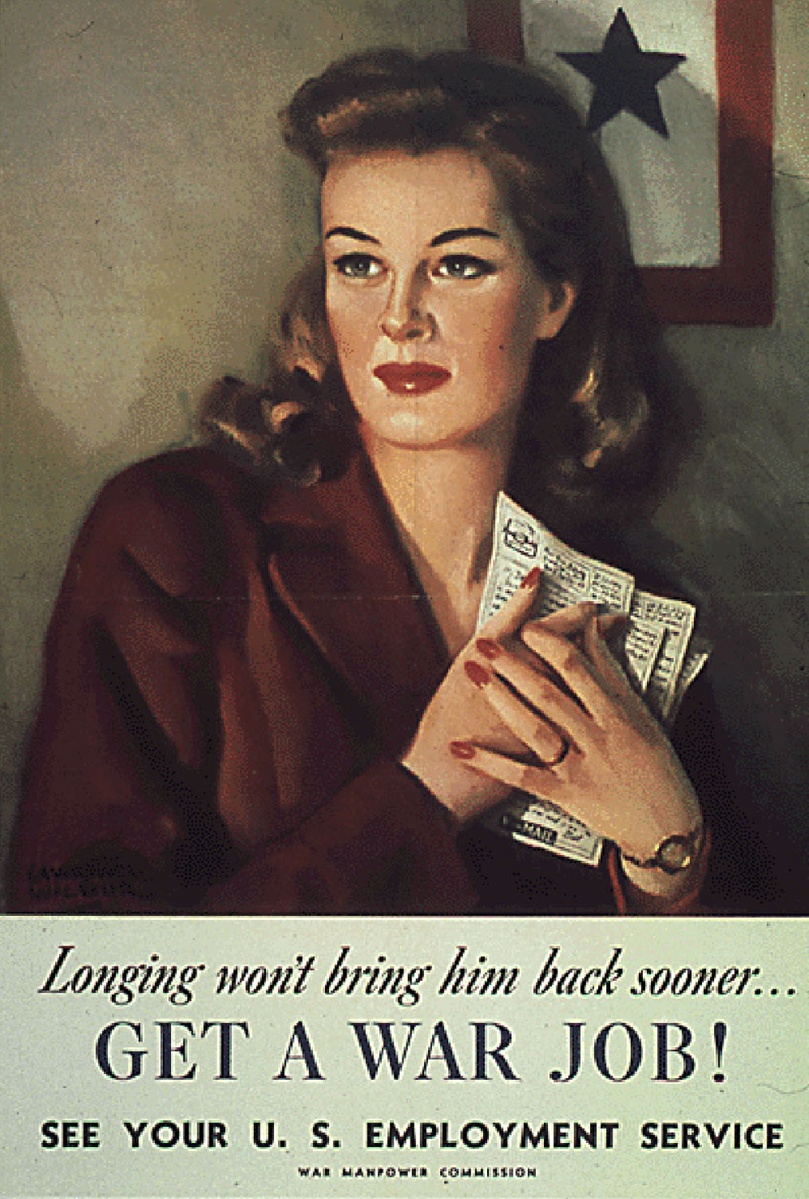

- “Women Needed to Help American Men Win This War,” 1941. (PSI Document. “Women Needed to Help American Men Win This War," 1942 - 1943. Office for Emergency Management. War Production Board. Record Group 179, Records of the War Production Board, Still Picture Records LICON, Special Media Archive Services Division, College Park, MD.)
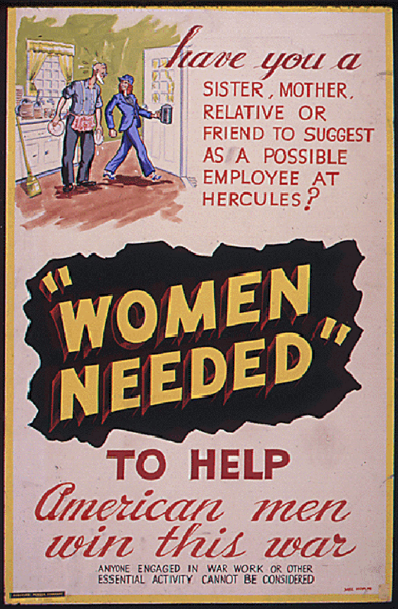

- “Keep These Hands Off,” 1941. (PSI Document. Office of Emergency Management, Office of War Information, Domestic Operations Branch, Bureau of Special Services, "Keep These Hands Off!," 1942-1945. Courtesy of LICON, Special Media Archive Services Division, National Archives, ARC Identifier: 513550.)

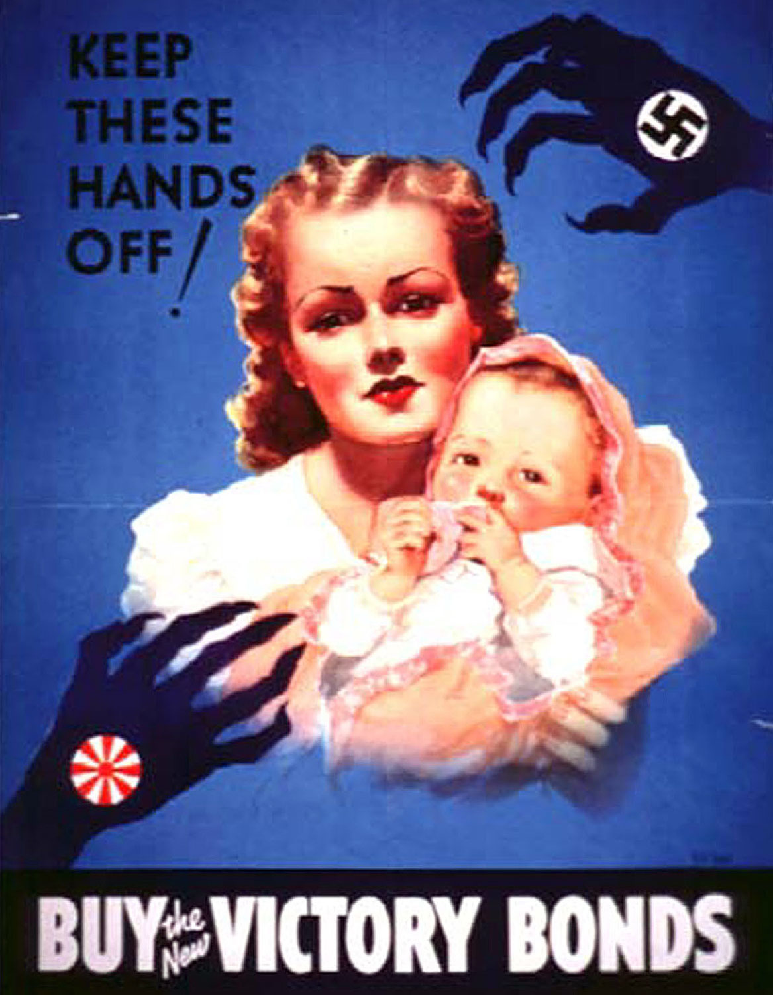

- “Women on the War Path,” 1942. (PSI Document. "Women On The War Path Need Paint." Office of Government Reports, United States Information Service Division of Public Inquiry, Bureau of Special Services. 1941-1945. Control Number: NWDNS-44-PA-2447 from the Still Picture Branch of the National Archives.)

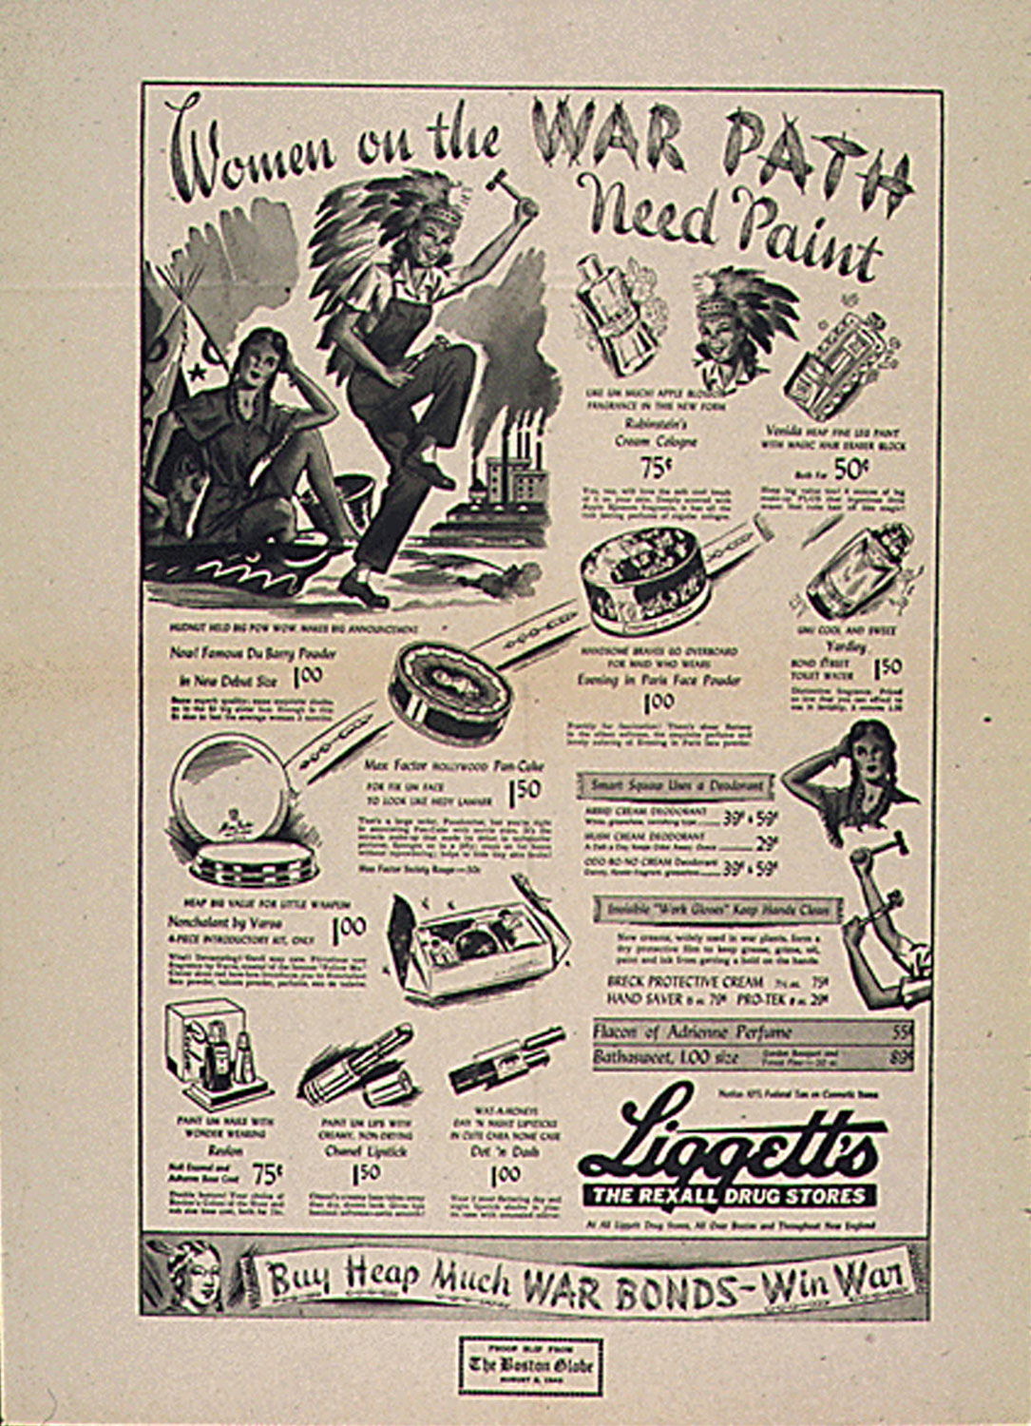

“Rosie the Riveter,” 1943. Located on the Primary Source Investigator CD-ROM.

Possible evidence:

- By the war’s end, the number of women in the work force had increased by almost 60 percent. The role of wage-earning women was felt especially in the industrial work force where they worked in war plants at jobs traditionally believed to be “men’s work”; in service-sector jobs where they worked as clerks, secretaries, and typists; and in the military within gender-segregated units like the WACs and the WAVEs. Women also joined unions in higher numbers than ever before.

- Women who elected to stay at home were also enlisted in the war effort. They were encouraged to raise victory gardens, can food, and prepare meals that fit their food ration coupons. Some were recruited by the USO to serve as hostesses in their clubs, and by military bases to join “dance brigades” where they had social evenings with soldiers.

- Many of the posters were designed specifically to convince women that it was their duty to join the work force and enter jobs that previously had been considered inappropriate for them. The “Soldiers without guns” poster sees hardworking women involved in domestic military jobs that required their devotion and fighting spirit. The “Victory Waits” poster is even more direct − it features a blond woman in ordinary clothing doing traditionally female secretarial work. By saluting the viewer, she is clear that it is no mere price list that she is typing, and links the seemingly trivial effort of pushing keys on a typewriter with the mountains of paperwork and bureaucracy needed to keep the Air Force's pilots flying. The “Women Needed” poster asks if anyone has "a sister, mother, relative or friend" to recommend for war production work. The small scene at the top shows a woman proudly heading off to work, lunch pail in hand and leaving her kitchen work to an older man who is obviously not of military age. It leaves the contemporary viewer wondering whether the woman shown here would return willingly to the kitchen at the end of the war. The most famous of all images is that of “Rosie the Riveter.” On this magazine cover, Rosie is a symbol for the nation's newest heroines: women who cross traditional gender boundaries to take up rough production work vacated by men as they left for war. Her bulging biceps, masculine watch band, confident pose, and rivet gun on her lap leave no doubt about her abilities.

- Some posters were aimed specifically at married women. While the woman in “Longing won't bring him back sooner” clutches several letters from her husband, the poster seeks to bring her back to reality by reminding her that "Longing won't bring him back sooner....” Perhaps if she gets a war job, she can shorten their separation.

- Many of the posters aim at military recruitment. The “Join the WAAC” poster shows a woman in uniform commanding women to join the war effort via the Women’s Army Auxiliary Corp.

- Another role for women is suggested in the “Keep These Hands Off” poster. All citizens, including mothers, should purchase "Victory Bonds" to help finance the war effort. This angelic mother and baby are juxtaposed with the animalistic, claw-like hands of our enemies. This ideal mother and wife became an effective tool of salesmanship and propaganda. The “Women on the War Path” advertisement for Rexall Drugs encourages women to support the war movement by buying war bonds and rationing their purchases.

Creative Extensions.

1. Before reading Chapter 28, take your class to the computer lab and have them go the interactive map, “World War II” in the Online Learning Center. After working with the map, have them answer all four questions at the OLC site. Then, bring the class together and ask them what they learned about World War II prior to the U.S. entrance into the war.

- After reading Chapter 28, give your class a pop essay quiz in which they will write for 20 minutes on the following: In Chapter 28, Dr. Brinkley states that World War II “changed the world as profoundly as any event of the twentieth century, perhaps of any century” (p. 739). Drawing upon resources from this chapter, as well as previous chapters in the book, agree or disagree with his statement.

3. Stage a classroom debate on any one of the following:

Resolved: World War II strengthened traditional gender roles.
Resolved: World War II was a good war.
Resolved: The U.S. dropped the atomic bomb in order to prevent the Russians from entering the war with Japan.
Resolved: It was inevitable that a great deal of hysteria arose about Japanese Americans after the bombing of Pearl Harbor.
Resolved: The U.S. Supreme Court’s decision in Korematsu v. U.S. (1944) was unconstitutional.

4. Assign a project in which ask students learn more about Japanese internment. Begin by showing them the documentary Rabbit In the Moon by Emiko Omori and discussing pertinent information from its companion Website at http://www.pbs.org/pov/pov1999/rabbitinthemoon/. Take students to the computer lab and have them read stories about internment written by the internees. (A good place to begin in the Densho Website at http://www.densho.org/.) Then, have them write a paper in which they use evidence from their research to address the following: Do you agree or disagree with the director of Rabbit in the Moon that the camps for the Japanese were not relocation camps but rather were concentration camps? How and why? Why do you think that there was no significant popular opposition to the camps?

5. Show your class the documentary The Good War (available at http://www.pbs.org/itvs/thegoodwar) about the role of Conscientious Objectors and other pacifists in World War II. After viewing the film, ask each each student to write a brief essay in which they agree or disagree with the following statement: During times of war, it is every American’s patriotic duty to serve in the military.

6. Stage a press conference to which you will invite several dictators and democrats from World War II: Roosevelt, Churchill, Hitler, Tojo, DeGaulle, Stalin, and Mussolini. Assign seven students the roles of each and require them to write a speech in which they will discuss their theory of government, military and diplomatic aims, and their opinions of one another. After each speech, allow members of the press (the remainder of the class) to ask questions. Then stage a second press conference to which you invite the following citizens: an African-American soldier, a female factory worker, a mother and homemaker, a Native America Code-Talker, a Japanese internee, a 19-year-old soldier, a Mexican zoot suiter, a bracero, a CIO labor organizer, a film-maker, a scientist on the Manhattan Project. Assign 10 students the roles of each and require them to write a speech in which they discuss what they did during the war, what they learned as a result of the war, and what their dreams are for life after the war. After each speech, allow members of the press (the remainder of the class) to ask questions.

7. Assign a research project in which students learn about the role of African Americans in World War II. Take them to the computer lab so that they can begin their own investigation on this topic. Ask them to begin by looking at the great Website on the History Place − http://www.historyplace.com/unitedstates/aframerwar/. Play an interview from National Public Radio with Kareem Abdul-Jabbar shortly after the 2004 publication of his book Brothers in Arms about the history of the all African American 761st Tank Battalion. (Available at http://www.npr.org/templates/story/story.php?storyId=1908299). Finally, play an interview between Tavis Smiley and Shawn Lindsey, publisher of Color of Service magazine, entitled, “The African American Soldier Today.” (Available at http://www.npr.org/templates/story/story.php?storyId=1566998). Then, assign the following essay: When the African American veterans returned to America after WWII, Abdul-Jabbar claims they questioned “whether the first fully democratic nation on paper would fulfill its promise” − its promises made in the Declaration of Independence (p. 253). Did America fulfill that promise? If so, how, why, and when?

8. Have students stage a trial in which Harry Truman, President of the United States, is tried for war crimes − specifically, for dropping two atomic bombs on Japan. A guideline for such a trial is available at The Educator’s Reference Desk at http://www.eduref.org/cgi-bin/printlessons.cgi/Virtual/Lessons/Social_Studies/World_History/WRH0209.html.

9. Assign students a group research project in which they select some technological innovation produced by American, British, German, or Japanese scientists − an innovation that contributed to the war effort. Working in groups of no more than four students, have them research the origins of their technological innovation, the way in which it was used during the war, and its overall contribution to science both during and after the war.

10. Invite students to watch any of the following three movies at home either with their family or with a group of friends from class: Saving Private Ryan, Band of Brothers (this HBO mini series has eight episodes), The Best Years of Our Lives, Patton, Bridge Over the River Kwai, Paths of Glory.

- What does this production tell you about World War II and American involvement in the war and on the home front?
- Do you think this film was a realistic portrayal of the historical event? Why or why not? Be specific.
- In your opinion, is this movie of any real use to understanding this period in American history? Be specific about how and why − or why not.

